SEC Form 4
FORM 4 |  | UNITED STATES SECURITIES AND EXCHANGE COMMISSION  Washington, D.C. 20549  STATEMENT OF CHANGES IN BENEFICIAL OWNERSHIP  Filed pursuant to Section 16(a) of the Securities Exchange Act of 1934  or Section 30(h) of the Investment Company Act of 1940
  OMB APPROVAL
  OMB Number: | 3235-0287
  Estimated average burden
  hours per response: | 0.5
 | Check this box if no longer subject to Section 16. Form 4 or Form 5 obligations may continue. See Instruction 1(b).
 | Check this box to indicate that a transaction was made pursuant to a contract, instruction or written plan for the purchase or sale of equity securities of the issuer that is intended to satisfy the affirmative defense conditions of Rule 10b5-1(c). See Instruction 10.
1. Name and Address of Reporting Person*  (Street) | 2. Issuer Name and Ticker or Trading Symbol  TANDEM DIABETES CARE INC [ TNDM ] | 5. Relationship of Reporting Person(s) to Issuer  (Check all applicable)
  Morrison Susan
  (Last) | (First) | (Middle)
  12400 HIGH BLUFF DRIVE
  SAN DIEGO | CA | 92130
  (City) | (State) | (Zip)
   | Director |  | 10% Owner
   | Officer (give title below) |  | Other (specify below)
  EVP & Chief Admin. Officer
3. Date of Earliest Transaction (Month/Day/Year)
05/29/2026
 | 4. If Amendment, Date of Original Filed (Month/Day/Year) | 6. Individual or Joint/Group Filing (Check Applicable Line)
  Form filed by One Reporting Person
  Form filed by More than One Reporting Person
Table I - Non-Derivative Securities Acquired, Disposed of, or Beneficially Owned
1. Title of Security (Instr. 3) | 2. Transaction Date (Month/Day/Year) | 2A. Deemed Execution Date, if any (Month/Day/Year) | 3. Transaction Code (Instr. 8) |  | 4. Securities Acquired (A) or Disposed Of (D) (Instr. 3, 4 and 5) |  |  | 5. Amount of Securities Beneficially Owned Following Reported Transaction(s) (Instr. 3 and 4) | 6. Ownership Form: Direct (D) or Indirect (I) (Instr. 4) | 7. Nature of Indirect Beneficial Ownership (Instr. 4)
1. Title of Security (Instr. 3) | 2. Transaction Date (Month/Day/Year) | 2A. Deemed Execution Date, if any (Month/Day/Year) | Code | V | Amount | (A) or (D) | Price |  | 6. Ownership Form: Direct (D) or Indirect (I) (Instr. 4) | 7. Nature of Indirect Beneficial Ownership (Instr. 4)
Table II - Derivative Securities Acquired, Disposed of, or Beneficially Owned
(e.g., puts, calls, warrants, options, convertible securities)
1. Title of Derivative Security (Instr. 3) | 2. Conversion or Exercise Price of Derivative Security | 3. Transaction Date (Month/Day/Year) | 3A. Deemed Execution Date, if any (Month/Day/Year) | 4. Transaction Code (Instr. 8) |  | 5. Number of Derivative Securities Acquired (A) or Disposed of (D) (Instr. 3, 4 and 5) |  | 6. Date Exercisable and Expiration Date (Month/Day/Year) |  | 7. Title and Amount of Securities Underlying Derivative Security (Instr. 3 and 4) |  | 8. Price of Derivative Security (Instr. 5) | 9. Number of derivative Securities Beneficially Owned Following Reported Transaction(s) (Instr. 4) | 10. Ownership Form: Direct (D) or Indirect (I) (Instr. 4) | 11. Nature of Indirect Beneficial Ownership (Instr. 4)
 |  |  |  | Code | V | (A) | (D) | Date Exercisable | Expiration Date | Title | Amount or Number of Shares
Restricted Stock Unit | (1) | 05/29/2026 |  | A |  | 29,136 |  | (2) | (2) | Common Stock | 29,136 | $0 | 29,136 | D
Explanation of Responses:
1. Each restricted stock unit (RSU) represents a contingent right to receive either one share of the Issuer's common stock or cash in lieu thereof, at the Issuer's discretion, in accordance with the terms of the Tandem Diabetes Care, Inc. 2023 Long-Term Incentive Plan, as amended, and agreements related thereto (the 2023 Plan).
2. One-third of such RSUs shall vest on 5/29/2027, and the remaining RSUs shall vest in eight (8) equal quarterly installments on the 15th of the month thereafter subject to the terms of the 2023 Plan.
Remarks:
Ex. 24: Power of Attorney
 | /s/ Jerilyn Laskie, Attorney-in-Fact for Susan M. Morrison | 06/02/2026
 | ** Signature of Reporting Person | Date
Reminder: Report on a separate line for each class of securities beneficially owned directly or indirectly.
* If the form is filed by more than one reporting person, see Instruction 4 (b)(v).
** Intentional misstatements or omissions of facts constitute Federal Criminal Violations See 18 U.S.C. 1001 and 15 U.S.C. 78ff(a).
Note: File three copies of this Form, one of which must be manually signed. If space is insufficient, see Instruction 6 for procedure.
Persons who respond to the collection of information contained in this form are not required to respond unless the form displays a currently valid OMB Number.
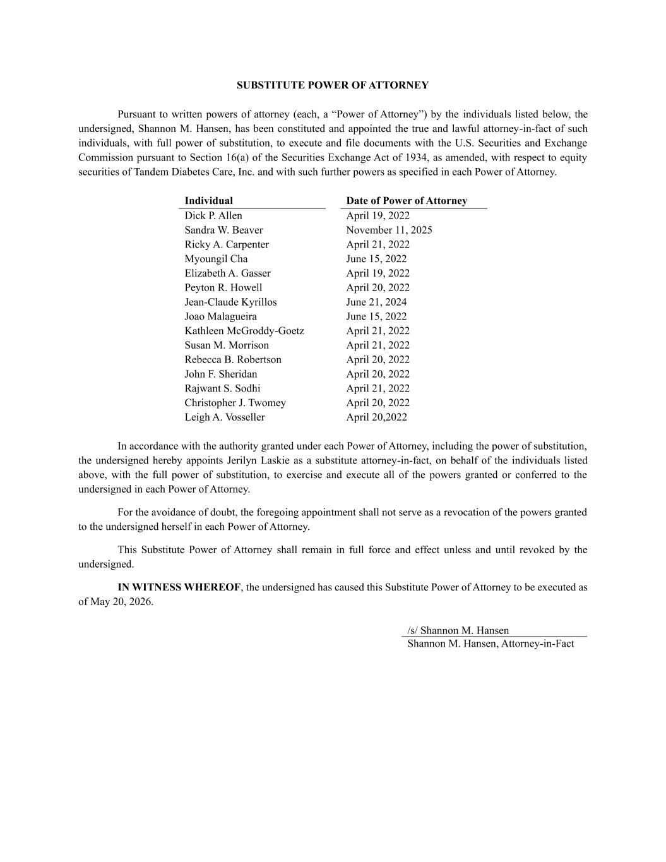
SUBSTITUTE POWER OF ATTORNEY Pursuant to written powers of attorney (each, a “Power of Attorney”) by the individuals listed below, the undersigned, Shannon M. Hansen, has been constituted and appointed the true and lawful attorney-in-fact of such individuals, with full power of substitution, to execute and file documents with the U.S. Securities and Exchange Commission pursuant to Section 16(a) of the Securities Exchange Act of 1934, as amended, with respect to equity securities of Tandem Diabetes Care, Inc. and with such further powers as specified in each Power of Attorney. Individual Date of Power of Attorney Dick P. Allen April 19, 2022 Sandra W. Beaver November 11, 2025 Ricky A. Carpenter April 21, 2022 Myoungil Cha June 15, 2022 Elizabeth A. Gasser April 19, 2022 Peyton R. Howell April 20, 2022 Jean-Claude Kyrillos June 21, 2024 Joao Malagueira June 15, 2022 Kathleen McGroddy-Goetz April 21, 2022 Susan M. Morrison April 21, 2022 Rebecca B. Robertson April 20, 2022 John F. Sheridan April 20, 2022 Rajwant S. Sodhi April 21, 2022 Christopher J. Twomey April 20, 2022 Leigh A. Vosseller April 20,2022 In accordance with the authority granted under each Power of Attorney, including the power of substitution, the undersigned hereby appoints Jerilyn Laskie as a substitute attorney-in-fact, on behalf of the individuals listed above, with the full power of substitution, to exercise and execute all of the powers granted or conferred to the undersigned in each Power of Attorney. For the avoidance of doubt, the foregoing appointment shall not serve as a revocation of the powers granted to the undersigned herself in each Power of Attorney. This Substitute Power of Attorney shall remain in full force and effect unless and until revoked by the undersigned. IN WITNESS WHEREOF, the undersigned has caused this Substitute Power of Attorney to be executed as of May 20, 2026. /s/ Shannon M. Hansen Shannon M. Hansen, Attorney-in-Fact

