SEC Form 4

FORM 4

Check this box if no longer subject to Section 16. Form 4 or Form 5 obligations may continue. See Instruction 1(b).

Check this box to indicate that a transaction was made pursuant to a contract, instruction or written plan for the purchase or sale of equity securities of the issuer that is intended to satisfy the affirmative defense conditions of Rule 10b5-1(c). See Instruction 10.

UNITED STATES SECURITIES AND EXCHANGE COMMISSION
Washington, D.C. 20549
Washington, D.C. 20549 |  | OMB APPROVAL
STATEMENT OF CHANGES IN BENEFICIAL OWNERSHIP
STATEMENT OF CHANGES IN BENEFICIAL OWNERSHIP |  | OMB Number: | 3235-0287
 |  | Estimated average burden
Filed pursuant to Section 16(a) of the Securities Exchange Act of 1934 |  | hours per response: | 0.5
or Section 30(h) of the Investment Company Act of 1940
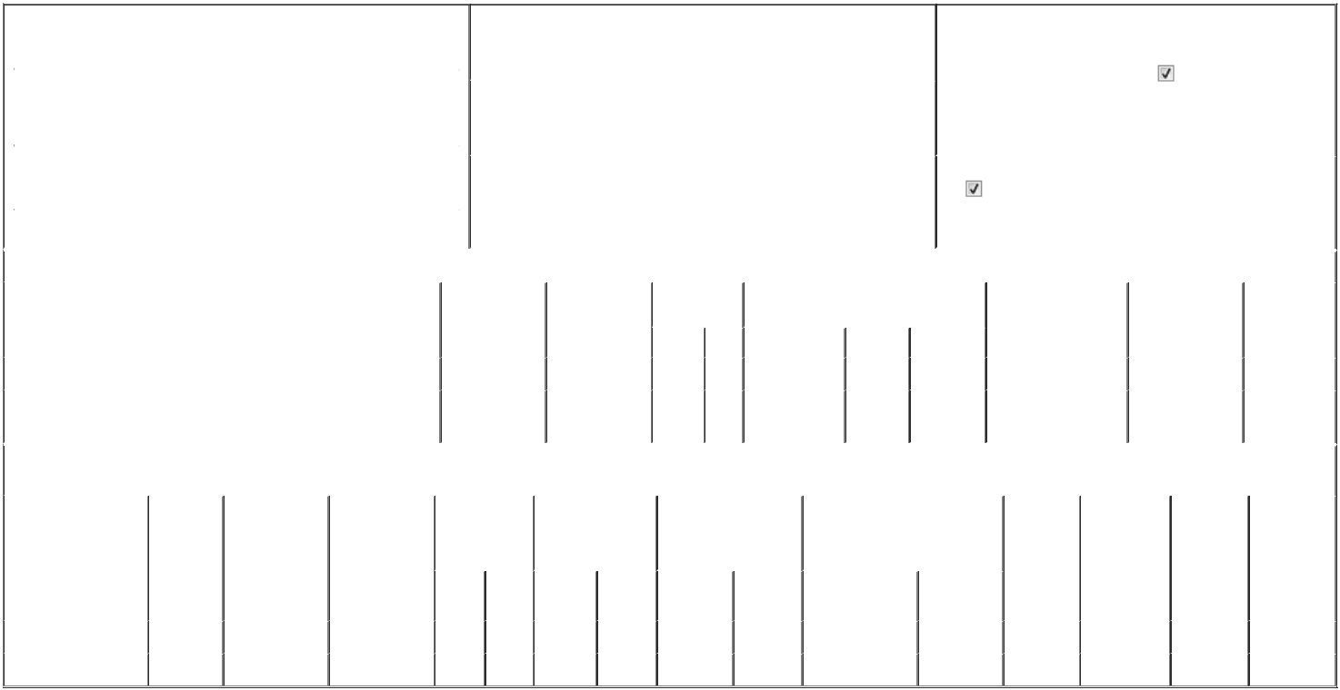

 | 1. Name and Address of Reporting Person* |  |  |  |  |  |  |  |  | 2. Issuer Name and Ticker or Trading Symbol |  |  |  |  |  |  |  |  |  | 5. Relationship of Reporting Person(s) to Issuer
 |  | Allen Dick |  |  |  |  |  |  |  | TANDEM DIABETES CARE INC [ TNDM ] |  |  |  |  |  |  |  |  |  | (Check all applicable)
 |  | Allen Dick |  |  |  |  |  |  |  |  |  |  |  |  |  |  |  |  |  |  |  | Director |  |  | 10% Owner
 |  |  |  |  |  |  |  |  |  |  |  |  |  |  |  |  |  |  |  |  |  | Officer (give title |  |  | Other (specify below)
 |  |  |  |  |  |  |  |  |  |  |  |  |  |  |  |  |  |  |  |  |  | below)
 |  | (Last) |  | (First) |  | (Middle) |  |  |  | 3. Date of Earliest Transaction (Month/Day/Year) |  |  |  |  |  |  |  |  |  |  |  | below) | Chair Emeritus
 |  | 12400 HIGH BLUFF DRIVE |  |  |  |  | 05/20/2026
 | (Street)
 |  |  |  |  |  |  |  |  |  | 4. If Amendment, Date of Original Filed (Month/Day/Year) |  |  |  |  |  |  |  |  |  | 6. Individual or Joint/Group Filing (Check Applicable Line)
 |  | SAN DIEGO |  | CA |  | 92130
 |  |  |  | CA |  | 92130 |  |  |  |  |  |  |  |  |  |  |  |  |  |  |  | Form filed by One Reporting Person
 |  |  |  |  |  |  |  |  |  |  |  |  |  |  |  |  |  |  |  |  |  | Form filed by More than One Reporting Person
 |  | (City) |  | (State) |  | (Zip)
 |  |  |  |  |  | Table I - Non-Derivative Securities Acquired, Disposed of, or Beneficially Owned
 | 1. Title of Security (Instr. 3) |  |  |  |  |  | 2. Transaction |  |  |  | 2A. Deemed |  | 3. Transaction |  | 4. Securities Acquired (A) or Disposed Of |  |  |  |  |  | 5. Amount of Securities |  |  | 6. Ownership |  | 7. Nature of
 |  |  |  |  |  |  | Date |  |  |  | Execution Date, |  | Code (Instr. 8) (D) (Instr. 3, 4 and 5) |  |  |  |  |  |  |  | Beneficially Owned |  |  | Form: Direct (D) or |  | Indirect
 |  |  |  |  |  |  | (Month/Day/Year) |  |  |  | if any |  |  |  |  |  |  |  |  |  | Following Reported |  |  | Indirect (I) (Instr. 4) |  | Beneficial
 |  |  |  |  |  |  |  |  |  |  | (Month/Day/Year) |  | Code | V | Amount |  |  | (A) or (D) | Price |  | Transaction(s) (Instr. 3 |  |  |  |  | Ownership
 |  |  |  |  |  |  |  |  |  |  |  |  | Code | V |  |  |  | (A) or (D) |  |  | and 4) |  |  |  |  | (Instr. 4)
 | Common Stock |  |  |  |  |  | 05/21/2026 |  |  |  |  |  | M |  | 8,759 |  |  | A | $0 |  | 28,146 |  |  |  | D
 | Common Stock |  |  |  |  |  |  |  |  |  |  |  |  |  |  |  |  |  |  |  | 22,757 |  |  |  | I | See
 |  |  |  |  |  |  |  |  |  |  |  |  |  |  |  |  |  |  |  |  |  |  |  |  | I | Footnote⁽¹⁾
 |  |  |  |  |  | Table II - Derivative Securities Acquired, Disposed of, or Beneficially Owned
 |  |  |  |  |  |  | (e.g., puts, calls, warrants, options, convertible securities)
 | 1. Title of Derivative |  |  | 2. | 3. Transaction | 3A. Deemed | 4. Transaction |  |  |  | 5. Number of |  | 6. Date Exercisable and |  |  |  | 7. Title and Amount of Securities |  |  |  |  | 8. Price of | 9. Number of |  | 10. | 11. Nature of
 | Security (Instr. 3) |  |  | Conversion | Date | Execution Date, | Code (Instr. 8) |  |  |  | Derivative |  | Expiration Date |  |  |  | Underlying Derivative Security |  |  |  |  | Derivative | derivative |  | Ownership | Indirect
 |  |  |  | or Exercise | (Month/Day/Year) if any |  |  |  |  |  | Securities Acquired |  | (Month/Day/Year) |  |  |  | (Instr. 3 and 4) |  |  |  |  | Security | Securities |  | Form: | Beneficial
 |  |  |  | Price of |  | (Month/Day/Year) |  |  |  |  | (A) or Disposed of |  |  |  |  |  |  |  |  |  |  | (Instr. 5) | Beneficially |  | Direct (D) or | Ownership
 |  |  |  | Derivative |  |  |  |  |  |  | (D) (Instr. 3, 4 and 5) |  |  |  |  |  |  |  |  |  |  |  | Owned |  | Indirect (I) | (Instr. 4)
 |  |  |  | Security |  |  |  |  |  |  |  |  |  |  |  |  |  |  |  |  |  |  | Following |  | (Instr. 4)
 |  |  |  |  |  |  |  |  |  |  |  |  |  |  |  |  |  |  | Amount or |  |  |  | Reported
 |  |  |  |  |  |  |  |  |  |  |  |  | Date |  | Expiration |  |  |  | Number of |  |  |  | Transaction(s)
 |  |  |  |  |  |  | Code V |  |  |  | (A) | (D) | Exercisable |  | Date |  | Title |  | Shares |  |  |  | (Instr. 4)
 | Restricted Stock Unit |  |  | (2) | 05/20/2026 |  | A |  |  |  | 10,220 |  |  | (3) | (3) |  |  | Common Stock | 10,220 |  | $0 |  | 10,220 |  | D
 | Restricted Stock Unit |  |  | (2) | 05/21/2026 |  | M |  |  |  |  | 8,759 |  | (4) | (4) |  |  | Common Stock | 8,759 |  | $0 |  | 0 |  | D

Explanation of Responses:

- The securities are held by the Allen Family Trust dated October 12, 1981.

- Each restricted stock units (RSU) represents a contingent right to receive either one share of the Issuers common stock or cash in lieu thereof, at the Issuers discretion, in accordance with the terms of the Tandem Diabetes Care, Inc. 2023 Long-Term Incentive Plan, as amended, and agreements related thereto (the 2023 Plan).

- Such RSUs were granted to the Reporting Person on May 20, 2026, and will vest on the one-year anniversary thereof, subject to the terms of the 2023 Plan.

- On May 21, 2025, the Reporting Person was granted 8,759 RSUs, all of which vested and converted into shares of the Issuers common stock on the one-year anniversary thereof in accordance with the 2023 Plan.

Remarks:

Ex. 24: Power of Attorney

 | /s/ Jerilyn Laskie, Attorney-in-Fact for |  |  | 05/22/2026
 | Dick P. Allen
 | ** Signature of Reporting Person |  |  | Date
Reminder: Report on a separate line for each class of securities beneficially owned directly or indirectly.
* If the form is filed by more than one reporting person, see Instruction 4 (b)(v).
** Intentional misstatements or omissions of facts constitute Federal Criminal Violations See 18 U.S.C. 1001 and 15 U.S.C. 78ff(a).
Note: File three copies of this Form, one of which must be manually signed. If space is insufficient, see Instruction 6 for procedure.
Persons who respond to the collection of information contained in this form are not required to respond unless the form displays a currently valid OMB Number.



